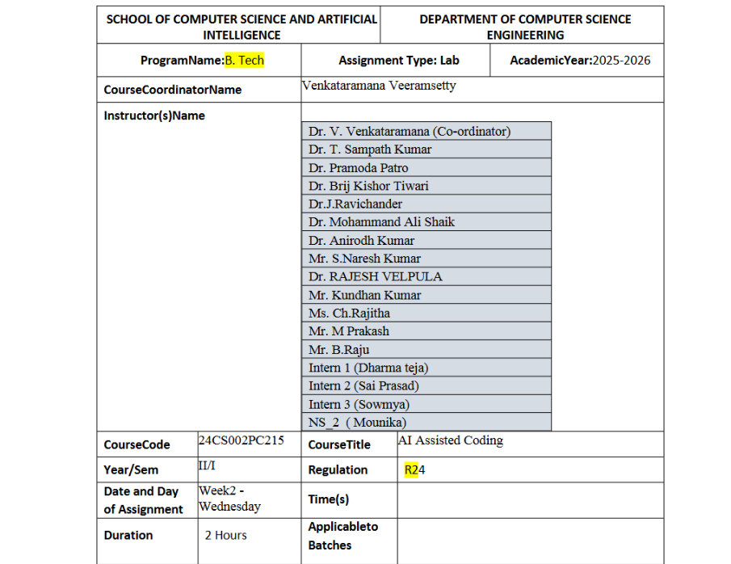
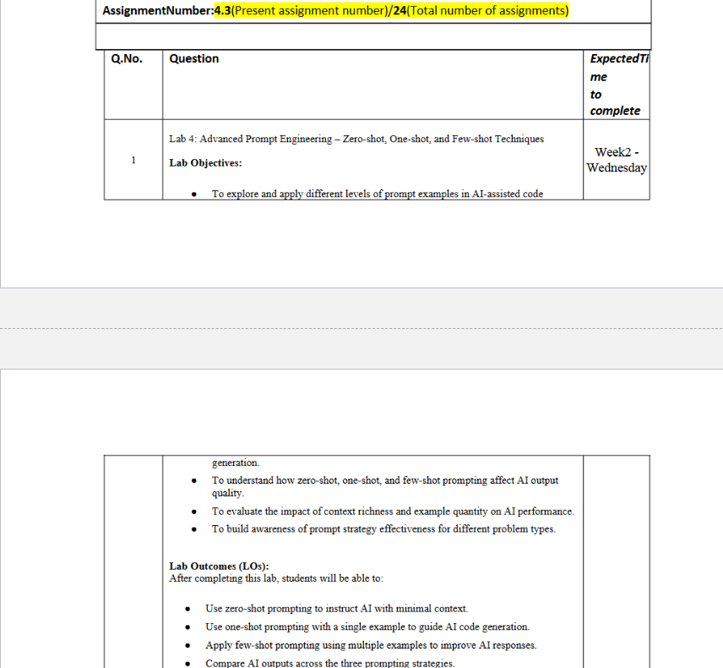
Task Description#1
● Zero-shot: Prompt AI to write a function that checks whether a given year is a leap
year.
Expected Output#1
● AI-generated function with no examples provided
CODE:
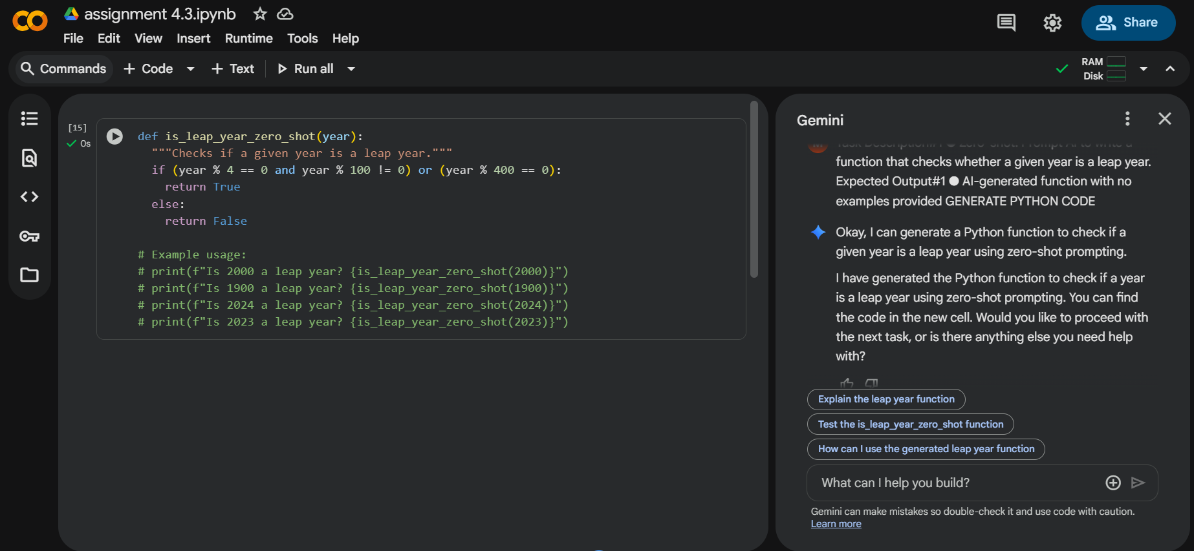
Task Description#2
● One-shot: Give one input-output example to guide AI in writing a function that
converts centimeters to inches.
Expected Output#2
● Function with correct conversion logic
CODE:
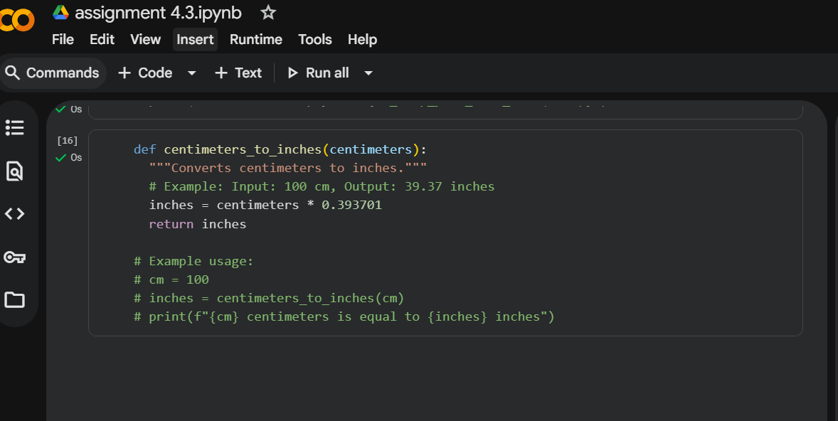
Task Description#3
● Few-shot: Provide 2–3 examples to generate a function that formats full names as
“Last, First”.
Expected Output#3
● Well-structured function respecting the examples
CODE:
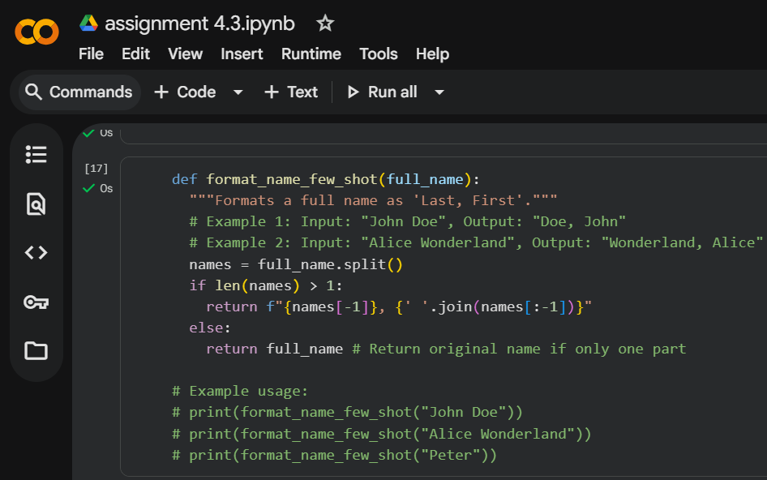
Task Description#4
● Compare zero-shot and few-shot prompts for writing a function that counts the
number of vowels in a string.
Expected Output#4
● Functional output and comparative reflection
CODE:
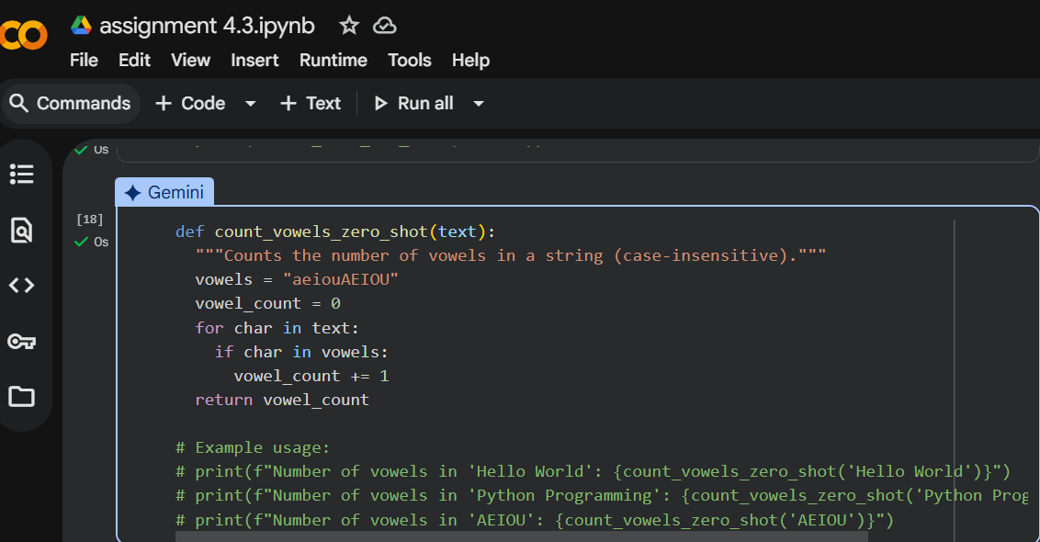
Task Description#5
● Use few-shot prompting to generate a function that reads a .txt file and returns the
number of lines.
Expected Output#5
● Working file-processing function with AI-guided logic
CODE:
